# About the Users

* We should have the roles: Admin, Secretary, and Doctor.

**Note**: The app will be managed by a doctor who can also have some patients assigned.

So basically, if a doctor is an admin, should be redirected to the admin views on login, and have two roles assigned.

* Doctor Roles: for example, Eye Doctor Leg Doctor etc.   
  **Note**: The admin should have the ability to add new doctor roles or to delete the old ones.

## Patient

We should have 3 types of patients.

1. Active: An active patient is the one who visits the clinic this period.
2. Inactive: An Inactive patient, has completed the treatment on the clinic or has gone to another clinic.
3. Not Subscribed: This type of patient has made a first contact with the secretary and is a potential patient.

* The patient’s profile should have the Basic information about the patient:

First name, last name, Date of Birth, Diagnosis (in diagnosis we should be able to add more than one element), telephone, email.

**Note**: Admin may have the ability of adding or deleting Diagnosis from the Diagnosis list (like the Doctors role)

* We should also have a section where we can add some more information of patient’s contacts (Relatives, Outside Doctors etc.)  
  The information we need about the Contact: Contact Type / Description (Relative, Outside Doctor etc.), First Name, Last Name, Address, Telephone (if it is possible to take more than one telephone), Email, Availability (What time of the day the contact is available. For ex. 10:00 – 14:00)

**Note**: Admin may have the ability of adding or deleting Contact Type / Description from the Contact Type / Description list (like the Doctors role).

* We need a section where the Doctors can write the session comments.  
  We should have different kind of comments (comment types) in different tabs, for example: General Comments, Doctor’s comments, Confidential Comment. **Note**:   
  - Admin may have the ability of adding or deleting Comment Type from the Comment Type List (like the Doctors role).  
  - Identically, we want the admin to manage which doctor can see which comment. For example: The Doctor’s comment can be seen be every doctor, but the Confidential comment only from the leg Doctor, or only from the Doctor with the name Spyros.
* We would like to have a section where only Admin and Secretary could upload files about the patient (docs, pdf). The doctors can see all the files about the patients that are assigned to them.

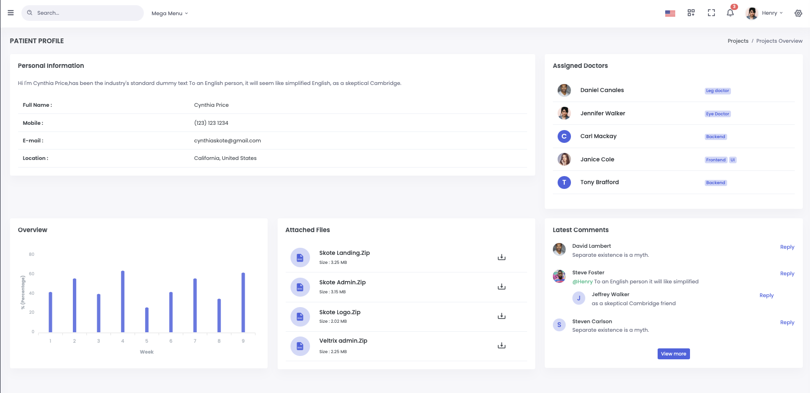  
Picture: Patient profile

## Doctors

* Can see only the patients that are assigned to them.
* In the patient’s profile, can see only the basic info of the patient (cannot see the info of the patient contacts), and the other doctors that are assigned on the patient.
* Can see the files of the patients that are assigned to them
* Can see and write only the type of comments that Admin has gave access.
* Can add or edit a session on his calendar.

## Secretary

* Can add new Doctor, Patient.
* Can see all the other Admins, Secretaries, Doctors Patients.
* Can assign a doctor to a patient.

## Admin

* Can add new Admin, Secretary, Doctor, Patient.
* Can see all the other Admins, Secretaries, Doctors Patients.
* Can assign a doctor to a patient.
* Can manage all the lists and the rights of what doctors can and cannot see.

## Features

* Chat between Admins, Secretaries, Doctors
* Email to doctors
* When a patient assigned on the doctor
* When someone write a new comment about one of his patients (only if has access on the specific comment type).
* When a session added or edited or deleted on the calendar